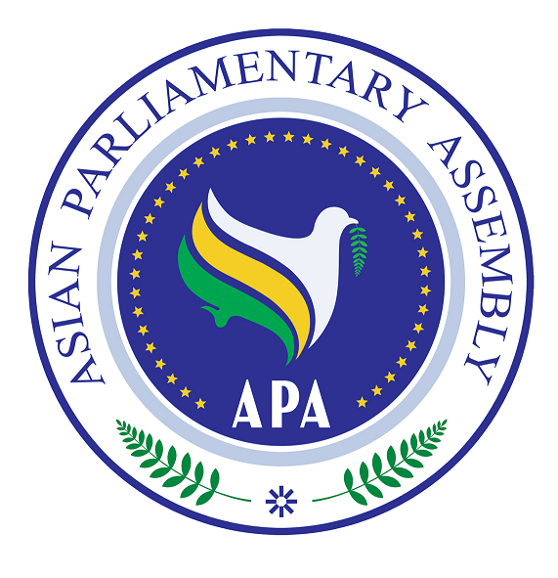
Asian Parliamentary Assembly (APA)

REGISTRATION FORM
APA Coordinating Meeting on the Sideline of the 146th IPU Assembly
Venue: Grand Hall E-Hollow Square 1
(Saturday 11 March 2023, at 10.30 AM)
Manama- The Kingdom of Bahrain

Please fill in one registration form for each participant (in block capitals) and return it to APA Secretariat at the following e-mail address latest by 05 March.
- Delegation of: …………

- Title: Please check Mr. Ms. Dr. other
- First Name:
- Last Name:

- Position in the parliament
……………………………………………………………………………………

- Phone No. | - …………………..……………………………………………..  - Country Code City Code Number
- Cell phone  - Fax No. | - …………………………………………………………………  - ………………………………………………………………..
- Email Address: | - ……………….……………………………………………..

Any Proposal on Emergency Item:

